Using the Fault Tree Analysis Profile
Note: This document is out of date and is currently being revised. The name of the profile has changed from Safety Analysis Profile to FTA Profile, and elements have been added and modified from this document.

Installation
The profile should be installed in the Rhapsody installation directory folder, under Share/Profiles.

- Copy the SafetyAnalysisProfile.zip file to the <installation directory>/Share/Profiles directory
- Unzip the file with the create directories option on.
This will create a directory called FTA

That’s it!

Creating a model with the profile
Use the File→New menu option in Rhapsody to create a Safety analysis project.
- Add the project name and locations you want
- In the Type drop-down list, select FTAProfile
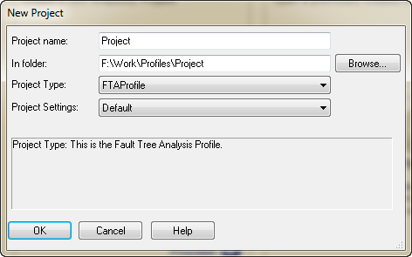

This will create a new model with the profile.

Adding the profile to an existing model
Use Rhapsody’s Add To Model feature to add the profile, then change the project type to FTAProfile type.
- Use File->Add Profile To Model.. to open the dialog
- Select FTAProfile.sbs
- Check Add Dependents checklist
- Click on As Reference radio button
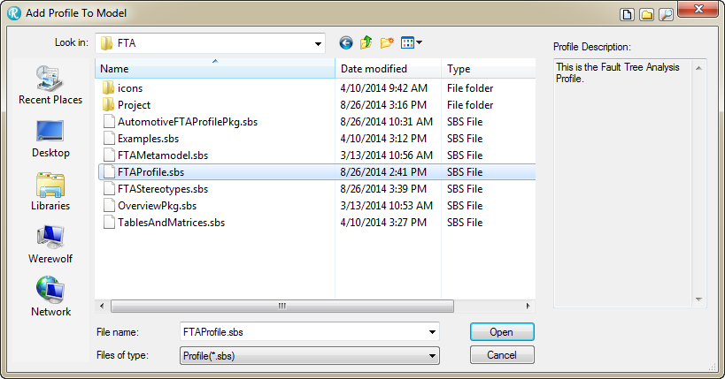
- Click on Open
- Once the profile is added, navigate to the project in the browser window (very first line).
- Right click on the project, select Change To->Safety
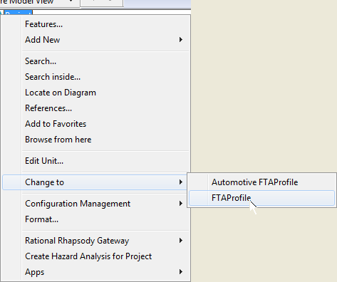

Adding a Fault Tree Analysis Model
Once you’ve created a fault tree analysis model, you have the full power of UML plus the ability to add Fault Tree and safety analysis diagrams and analyze them. We recommend creating a separate package in your model to hold your safety analysis elements and diagrams.

The diagram toolbar (normally located at the top of the Rhapsody window), should now have safety analysis and FTA diagram option:

Clicking on the FTA Diagram button will create a new FTA diagram. In addition, the Add New right click menu has been extended. If you select a package and right click you will see two new primary categories added; one of these adds semantic elements (e.g. hazards, faults, etc) and FTA diagrams while the other adds various summary tables and matrices.

The list of semantics elements includes FTA diagrams, semantic elements, logical operators, and various relations, seen below:

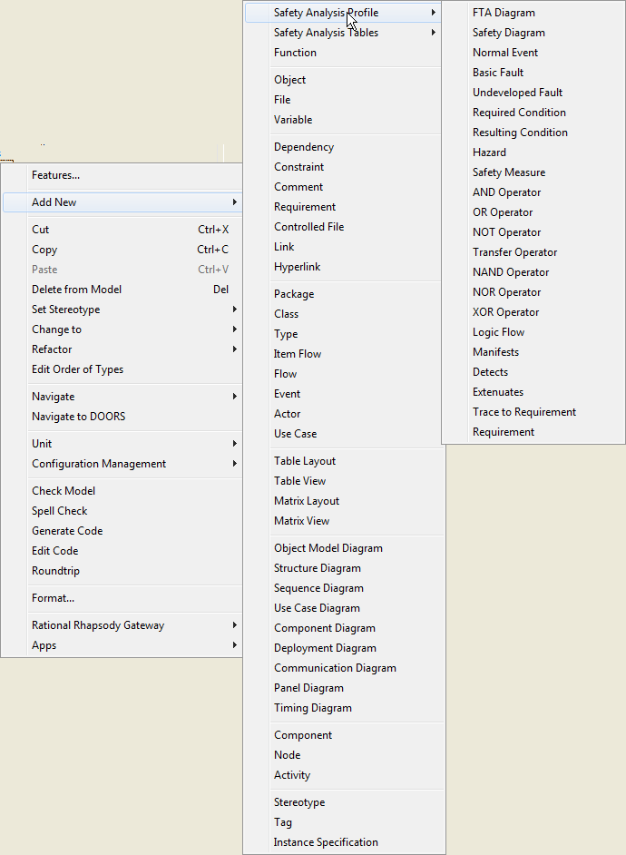

The other menu adds tables and matrices, including FMEA:

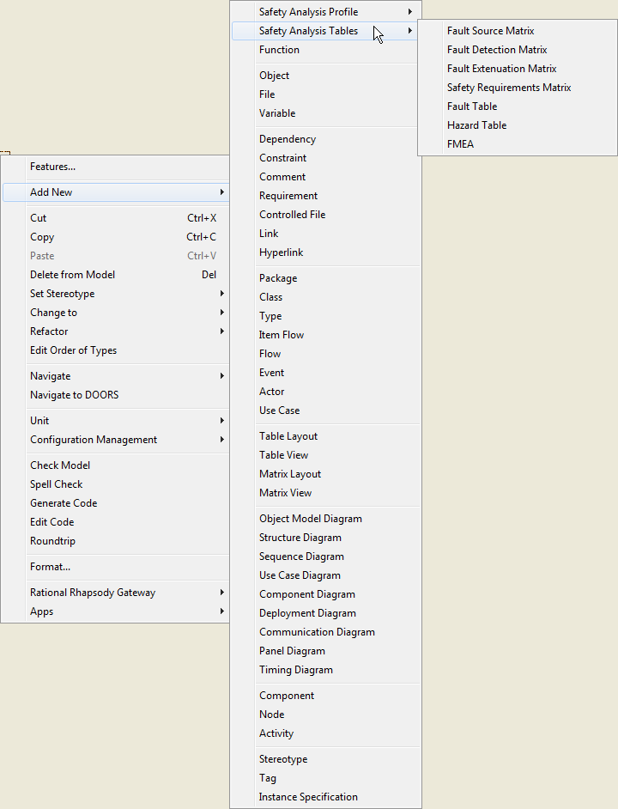

The key elements for the metamodel (along with their profile realizations) are:
Elements:
- Fault – the non-conformance of an element to its specification or expectation. Faults are further subclassed into Basic Faults and Undeveloped Faults. These are usually the bottom terminal elements in an FTA. (Stereotype of Class)
- Fault Source – this is a normal UML element that could manifest a fault, i.e. that could be the source of a fault. (Stereotype of Class)
- Hazard –a condition that will lead to an accident or loss. This is usually the top terminal element in an FTA. (Stereotype of Class)
- Hazardous Event - an event closely correlated with manifestation of a hazard
- Logical Operator – one of several logic conjunctives, such as AND, NOT, OR, etc. Note that Transfer operator actually has no semantics of its own but is used as a “diagram connector”, allowing large FTAs to be broken up across multiple diagrams. (Stereotype of Class)
- Logic Flow – the connection of a fault, condition or hazard to a Logical Operator. The logic flow can be an input or an output. For example, in the statement A || B → C, there is a flow output from A as an input to the || (OR) operator. There is also an output from flow the || operator to the resulting condition C. (Stereotype of Flow).
- Resulting Condition – the condition resulting from a combination of faults and conditions, combined with logical operators. (Stereotype of Class)
- Required Condition – A condition required for the fault to interact. (Stereotype of Class)
- Normal Event – an event normally associated with the operation of the system
- Safety Goal – a high level safety objective, this can be thought of an an abstract requirement that contains specific safety requirements
- Safety Measure - a specification of a solution to control or obviate the safety goal
- Safety Requirement – a specific testable safety requirement

Relations
- Allocate relation – used for allocation of a safety relevant element (e.g. a safety requirement or a control measure) to a design element (e.g. block, class, subsystem, activity, state, or function)
- Contributes relation – a Safety Goal contributes to (addresses) one or more Hazards
- Contains – a Safety Goal contains one or more Safety Requirements
- Implements – design elements implement one or more Safety Measures, Safety Goals, or Safety Requirements
- Realizes – a Safety Measure realizes a Safety Goal
- Detect relation – this is a relation from a Fault or Hazard to a Safety Measure that can detect when the fault has occurred. (Stereotype of Dependency)
- Extenuates relation – this is a relation from a Fault or Hazard to a Safety Measure that reduces either the likelihood or severity of the hazard or fault. (Stereotype of Dependency)
- Manifest relation – this is a relationship from a Fault to a Fault Source that causes the fault (Stereotype of Dependency)
- Trace To Requirement – this is a relation from a Fault or Hazard to a Requirement. (Stereotype of Dependency)

Faults and Hazards elements have important metadata characterizing them. The important metadata is summarized

Metaclass | Metadata | Description
Hazard | Fault Tolerance Time | This is the length of time the fault can be tolerated before it leads to an accident.
Hazard | Fault Tolerance Time Units | This is the units of time (e.g. ms, seconds, hours, days)
Hazard | Risk | Risk is the product of the severity times the probability
Hazard | Severity | The degree of damage the accident can cause
Hazard | Safety Integrity Level | For standards such as IEC65-1508, this is the identified SIL level
Hazard | Probability | The likelihood of occurrence of the hazardous condition, usually computed from the metadata of the faults
Fault | Action Taken | The likelihood the fault will occur
Fault | Cause | Whyfore the fault
Fault | Current Controls | What measures are already in place in the design
Fault | Detection Mechanism | How is the fault detected
Fault | Effect | What happens when the fault occurs
Fault | Failure Mode | How does the failure manifest
Fault | Probability | The likelihood the fault will occur
Fault | MTBF | The Mean Time Between Failure for the element
Fault | MFBF Time Units | The time units expressed in the MTBF meta-attribute
Fault | Recommended Action | What should be added to the fault response
Fault | Risk Priority | Product of severity, likelihood and detectability
Fault | Severity | How bad is it when the fault occurs
Fault | System Function | What functions does this fault cause to fail
Fault Source | Fault Mechanism | A description of how the fault can occur
Safety Measure | Fault Action Time | The length of time the corrective action requires to complete once initiated
Safety Measure | Fault Detection Time | The length of time, from the occurrence of the fault to its detection
Safety Measure | Fault Time Units | The unit of time used in the Fault Action Time and the Fault Detection Time
Safety Measure | Safety Mechanism | A description of how the detection and/or safety action is performed
Safety Measure | SIL | Safety Integrity Level (standard specific)
Table 1: Safety Metadata

Tables, Matrices and Hazard Analyses
In addition to the elements of the profile, new tables and matrices are added in the profile as well.
Table or Matrix | Format | Description
Fault Table | Rhapsody Table View | This lists the faults and all their metadata
Hazard Table | Rhapsody Table View | This lists the hazards and all their metadata
FMEA | Rhapsody Table View | Fault Means and Effect Analysis
Fault Source Matrix | Rhapsody Matrix View | This shows a fault x fault source matrix, as defined by the Manifests relations
Fault Detection Matrix | Rhapsody Matrix View | This shows a fault x safety measure matrix, as defined by the Detects relations
Fault Extenuation Matrix | Rhapsody Matrix View | This shows a fault x safety measure matrix, as defined by the Extenuates relations
Hazard Analysis | Tab-separated value text file (.tsv) intended to load into Excel | This is an external file generated by the profile helper macros summarizing the hazard and fault information.
Table 2: Tables and Matrix summary views

The Hazard analysis is generated as an external file with a helper macro. This macro scans the entire model and generates the tab-separated value file that can be loaded into most spreadsheet programs. The macro generates the name from the current date and time so that multiple versions of the hazard analysis can be kept. The output is divided into three sections.

The first section lists the hazards and their metadata, including the description, fault tolerance time, fault tolerance time units, probability, severity, risk, and safety integrity level.

The second section lists the relations between the faults and the hazards as defined by multiple intervening logical operators and logic flows. Each fault is identified with is name, description and other metadata.

The third section lists the relations between the faults and the “normal” UML model elements – requirements and classes related with the manifests, detects, extenuates, and traceToReqs relations.

For example, a Fault Table looks like this:

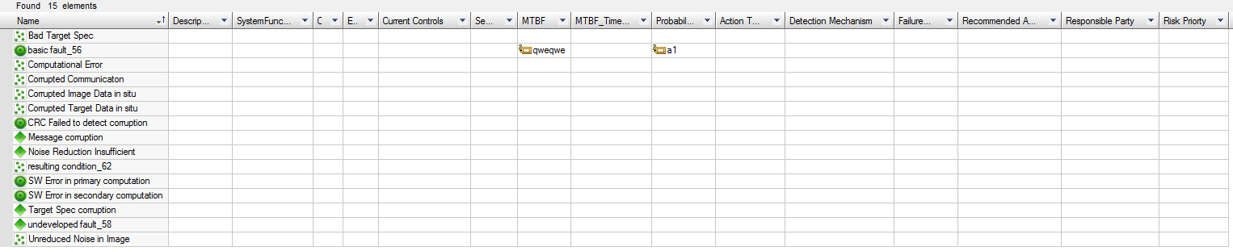

The hazard analysis is a generated external provides a summary with enough information to trace from the safety requirements to the model elements realizing those requirements, as well as from the faults and hazards to the requirements and design.

Adding a table
Tables and matrices can be added by selecting a package location in the browser, right clicking, selecting Safety Analysis Tables and then selecting the table or matrix of interested. The fault scope of the table is the entire model. If you wish to limit the scope to a package, right click on the newly added table and select “Features.” This opens the Features dialog. Select the desired scope on the General tab of the dialog.

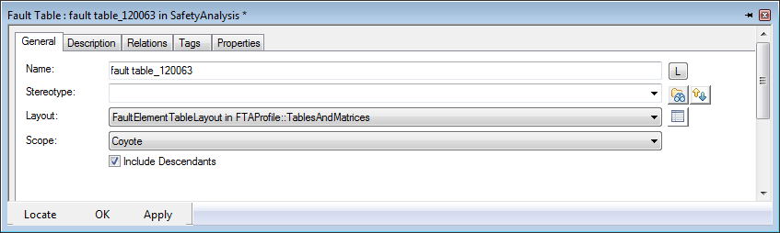

Tables and matrices are always within a defined scope that is specified in the Features dialog for the table or matrix.
Tab-separated value format was used because Excel™ has defects in its interpretation of the more-common comma-separated value (CSV) file format.

